**5. Git – HOL**

**Objectives:**

* Learn how to clean up your local repository.
* Push your latest changes to the remote Git repository.

**Hands-on Lab Steps:**

1. **Verify if master is in a clean state.**
   * **Purpose:** To ensure there are no uncommitted changes in your working directory.
   * **Command:** In your Git Bash shell, execute:

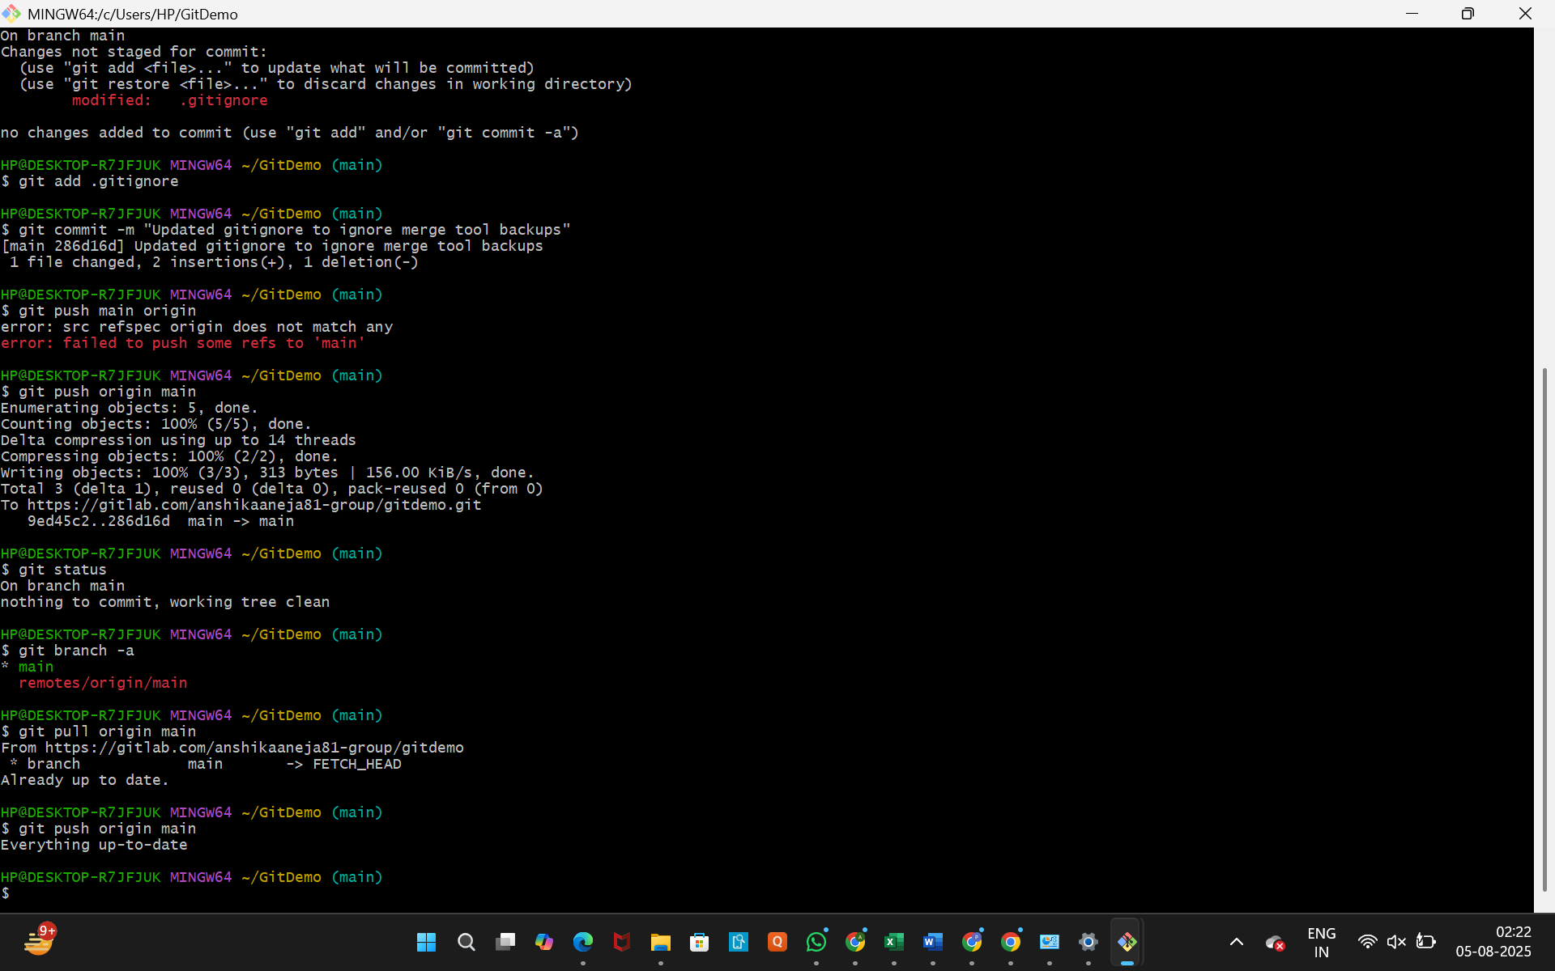

* + **What to expect:** You should see On branch main and nothing to commit, working tree clean.

1. **List out all the available branches.**
   * **Purpose:** To see all the local and remote branches in your repository. This is a good habit for understanding the state of your project.
   * **Command:**



* + **What to expect:** You should see a list of your local branches (e.g., main) and any remote-tracking branches (e.g., remotes/origin/main).

1. **Pull the remote Git repository to the master.**
   * **Purpose:** To download any changes from the remote repository to your local main branch, ensuring your local copy is up to date.
   * **Command:**



* + **What to expect:** Git will download and integrate any new commits. You will likely see a message like Already up to date. if no new changes were made on GitLab.

1. **Push the changes to the remote repository.**
   * **Purpose:** This is the final step to send any commits you've made locally to the remote repository on GitLab. The lab ID "Git-T03-HOL_002" is a label for the set of changes you are now pushing.
   * **Command:**



* + **What to expect:** Git will show you a summary of the commits being pushed, and you will see a message confirming the push was successful.

1. **Observe if the changes are reflected in the remote repository.**
   * **Purpose:** To visually confirm that your local work is now live on GitLab.
   * **Action:** Go to your GitDemo project page in your web browser and refresh the page.
   * **What to expect:** You should see the most recent commits at the top of the commit list, and the file list should be fully up to date with all your latest changes.

